Practical No. 7

Name : Danish Altaf Solkar Class : CO - B
Enrolment no. : 24111590805 Batch : 2

Aim : Write C / Python program to calculate Average Waiting Time and Turnaround Time of n processes with Round Robin (RR) scheduling algorithm

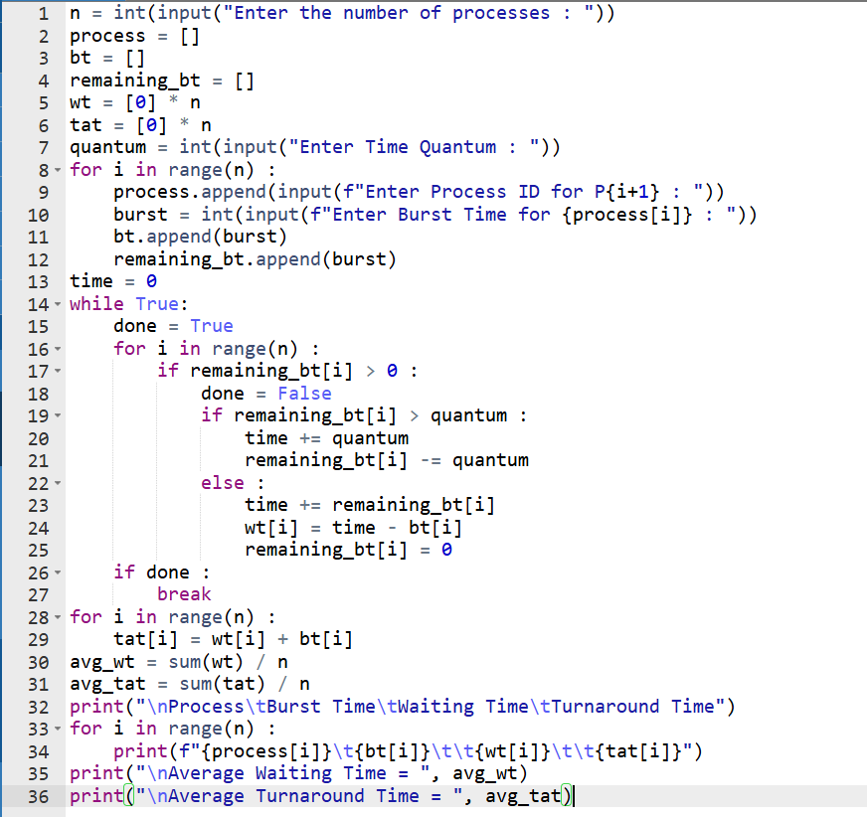

Output :-

